Constraints:
Q.1)Basic contraints:Create a table student where
- Stud_id is compulsory
- Name should not be null
- Email can not be null
- Collegename can not be null
- Apply default pin to colgAddres
Output:
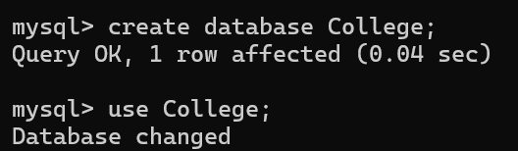

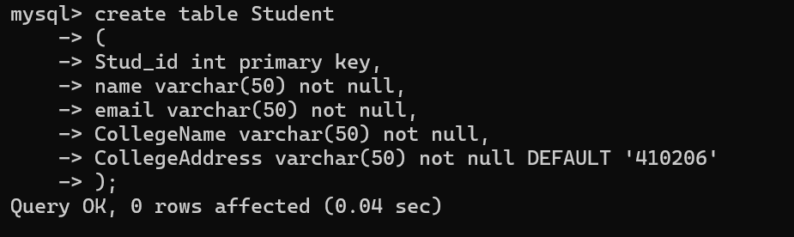

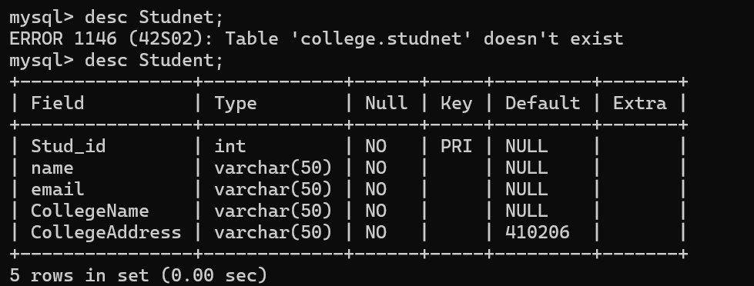



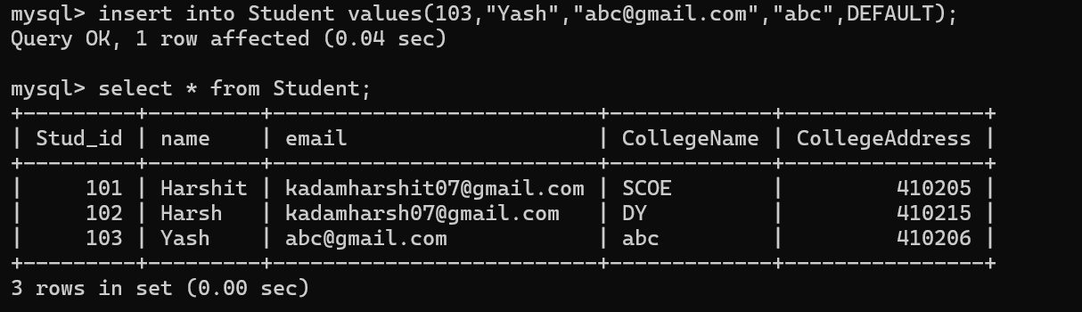

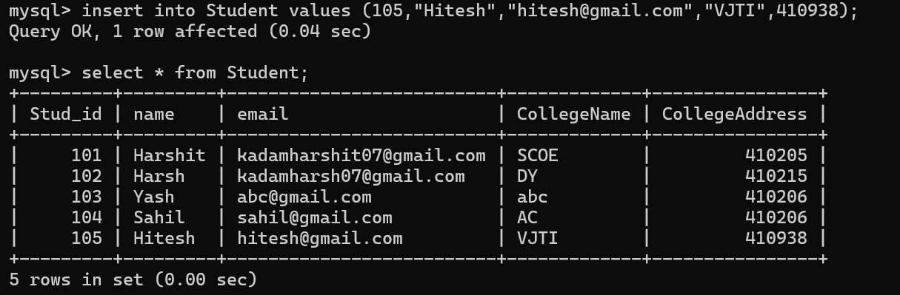

Q.2) Create table Departments where:
Dept_id is the primary key and Dept_name should be unique
Insert Minimum 5 values to show constraint

OUTPUT:

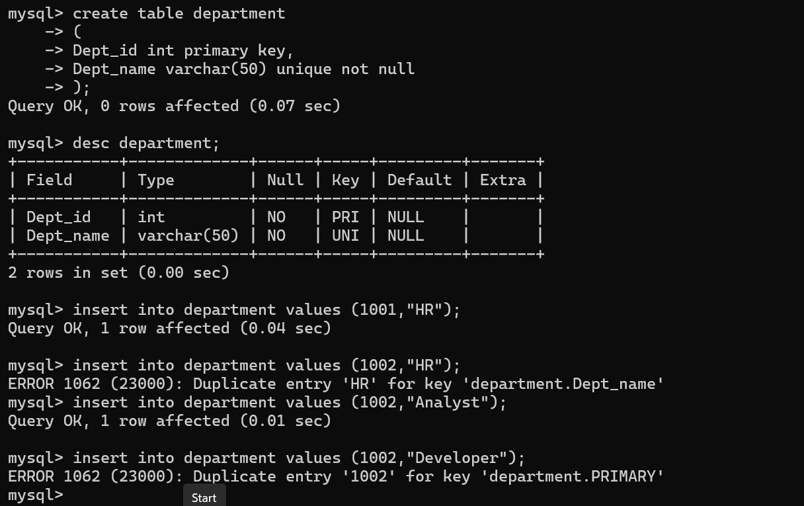



Q.3) Create Users Table where Username must be unique and password can not be NULL
Insert Minimum 5 values to show constraint

OUTPUT:

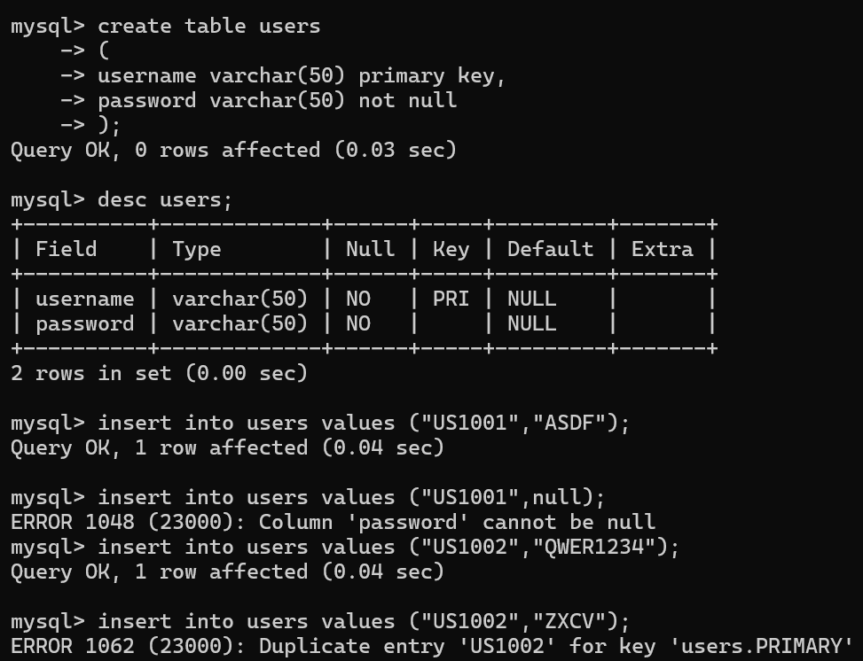

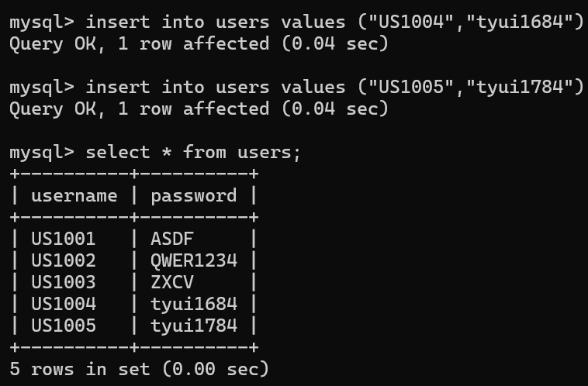

Q.4) Create a table Products where
- Price must be greater than 0
- Quantity must be atleast 1
Insert Minimum 5 values to show constraint

OUTPUT:
